PSS3 Report

Taszid Chowdhury

Simple Documentation for jfreechart-1.5.0.jar

1. Overview

jfreechart-1.5.0.jar is a Java library that provides tools to generate a variety of charts and graphs. It is widely used for embedding dynamic and static charting capabilities into Java applications.

1. Features
   1. Chart Types:
      1. Line charts
      2. Bar charts
      3. Pie charts
      4. Area charts
      5. Scatter plots
      6. Time series charts
      7. Gantt charts
      8. Customizable XY charts
   2. Customizations:
      1. Themes and styles
      2. Annotations
      3. Labels and legends
      4. Axis customizations (e.g., logarithmic scales)
   3. Interactivity:
      1. Zooming
      2. Tooltips
      3. Click events
2. Dependencies
   1. Requires Java Development Kit (JDK) version 8 or later.
   2. Some charts may need additional libraries, such as jcommon.

Simple Documentation for commons-math3-3.6.1.jar

1. Overview
   1. commons-math3-3.6.1.jar is part of the Apache Commons Math library. It provides comprehensive mathematical and statistical tools for Java applications, including analysis, optimization, algebra, and probability.
2. Features
   1. Mathematics and Analysis:
      1. Complex numbers
      2. Special functions (e.g., Gamma, Beta functions)
      3. Polynomials and root-finding
      4. Matrix algebra
      5. Linear and nonlinear equations
   2. Statistics:
      1. Descriptive statistics (mean, variance, etc.)
      2. Distribution fitting (e.g., Gaussian, Poisson)
      3. Random number generation
      4. Hypothesis testing
   3. Optimization:
      1. Univariate and multivariate optimization
      2. Nonlinear least-squares fitting
      3. Linear programming
   4. Utilities:
      1. Interpolation
      2. Fast Fourier Transform (FFT)
      3. Clustering algorithms
3. Dependencies
   1. Requires Java 1.6 or later.
   2. Lightweight with no additional dependencies.
4. Example Usage
   1. Here is a basic example using the library to compute statistical measures and solve equations.

Plotter.java

**Purpose:**

Generates data for a quadratic function, saves it to a CSV file, and creates a visual plot using JFreeChart.

Key Features:

* Input Parameters:
  + start: Start of the range for the x values.
  + end: End of the range for the x values.
  + interval: Increment value for x.
  + fileName: Name of the output CSV file.
* Core Functionality:
  + Computes y values for a quadratic function
  + Saves the (x, y) data points in CSV format.
  + Fits a polynomial curve to the generated data.
  + Generates an XY line chart for the data and saves it as a PNG file.
* Output
  + CSV file with (x, y) data points.
  + PNG chart of the quadratic function.

Salter.java

#### **Purpose:** Adds random noise (salt) to datasets to simulate noisy measurements and generates a scatter plot.

**Key Features:**

* Input Parameters:
  + inputFile: Path to the input CSV file.
  + outputFile: Path to save the salted data as a CSV.
  + saltRange: Maximum range of the random noise.
* Core Functionality:
  + Reads data from the input CSV.
  + Adds random noise to the y values within the range [−saltRange/2,saltRange/2][-saltRange/2, saltRange/2][−saltRange/2,saltRange/2].
  + Saves the salted data in CSV format.
  + Generates a scatter plot of the salted data and saves it as a PNG file.
* Output:
  + CSV file with noisy (salted) data points.
  + PNG scatter plot of the noisy data.

Smoother.java

#### **Purpose:**

Applies a moving average to noisy datasets to smooth the data and generates a scatter plot.

#### **Key Features:**

* Input Parameters:
  + inputFile: Path to the input CSV file with noisy data.
  + outputFile: Path to save the smoothed data as a CSV.
  + windowSize: Number of data points to include in the moving average.
* Core Functionality:
  + Reads data from the input CSV.
  + Applies a moving average to smooth the y values.
  + Saves the smoothed data in CSV format.
  + Generates a scatter plot of the smoothed data and saves it as a PNG file.
* Output:
  + CSV file with smoothed data points.
  + PNG scatter plot of the smoothed data.

PSS3Tester.java

#### **Purpose:**

Tests the functionality of Plotter, Salter, and Smoother classes using different data densities and parameter configurations.

Key Features:

* Test Cases for Plotter:
  + Small range, low density.
  + Moderate range, very low density.
  + Large range, high density.
  + Very large range, moderate density.

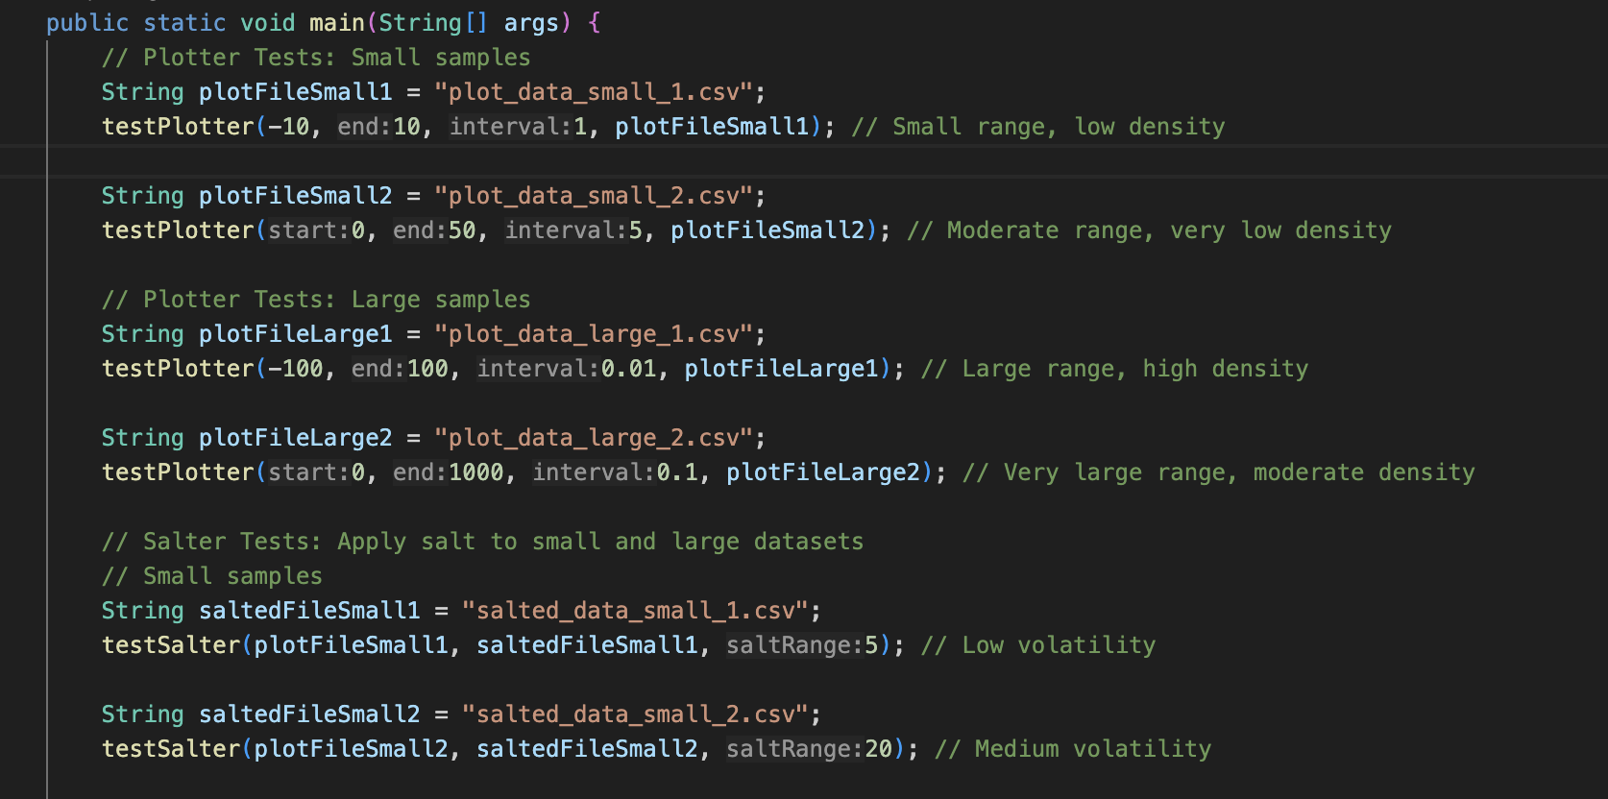

* Test Cases for Salter:
  + Adds noise to datasets using low, medium, and high volatility settings.

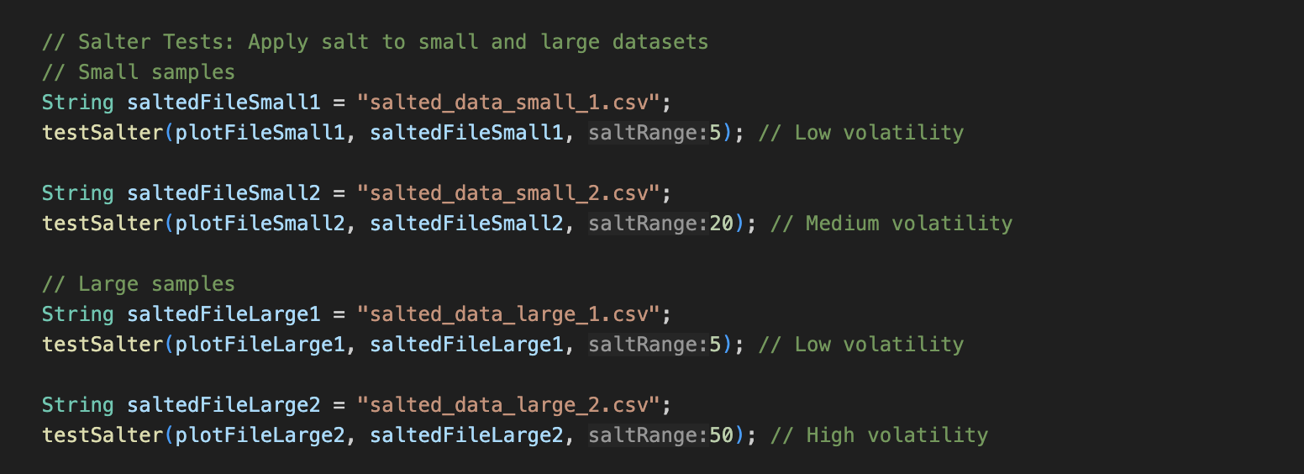

* Test Cases for Smoother:
  + Applies smoothing to noisy datasets with varying window sizes.

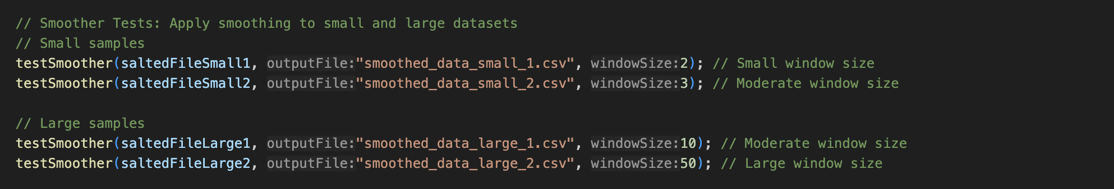

* Core Methods:
  + testPlotter: Generates data and saves it as a CSV using Plotter.
  + testSalter: Adds noise to datasets using Salter.
  + testSmoother: Applies a moving average to datasets using Smoothe

Code Screen Shots

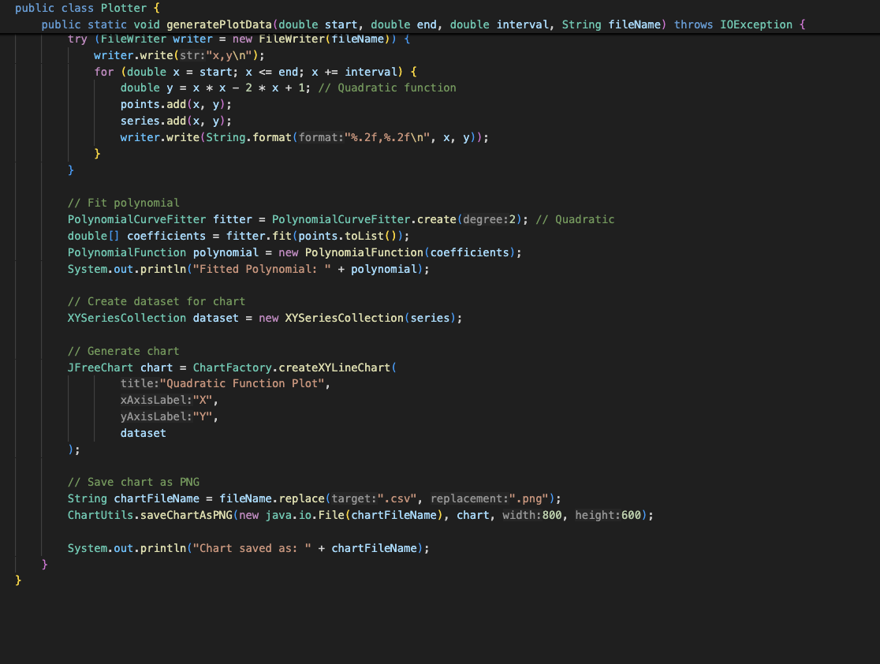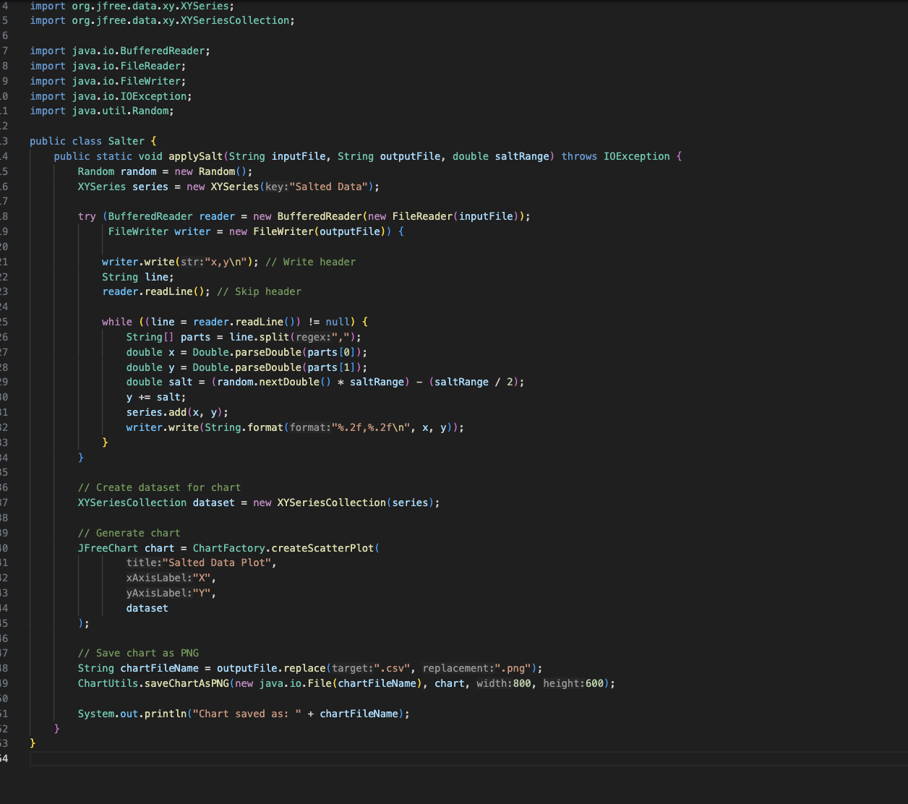

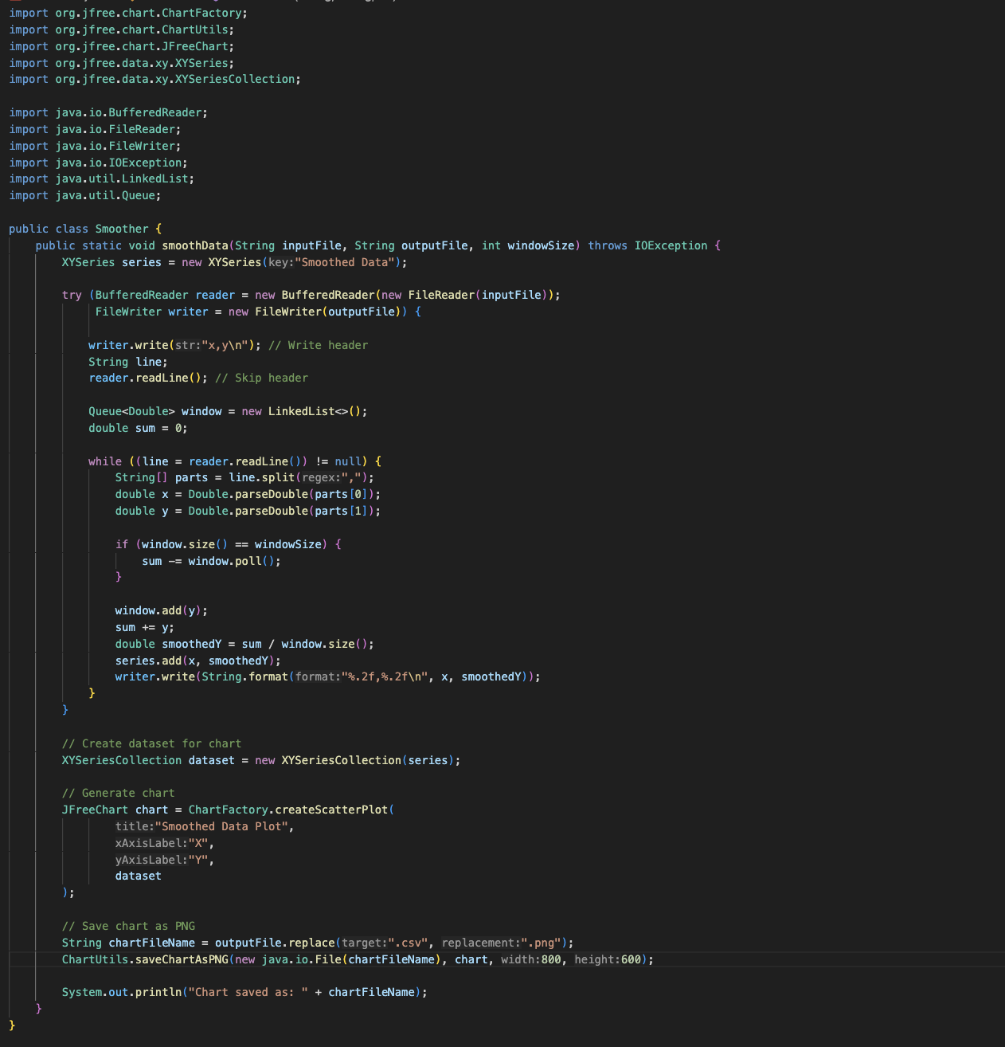

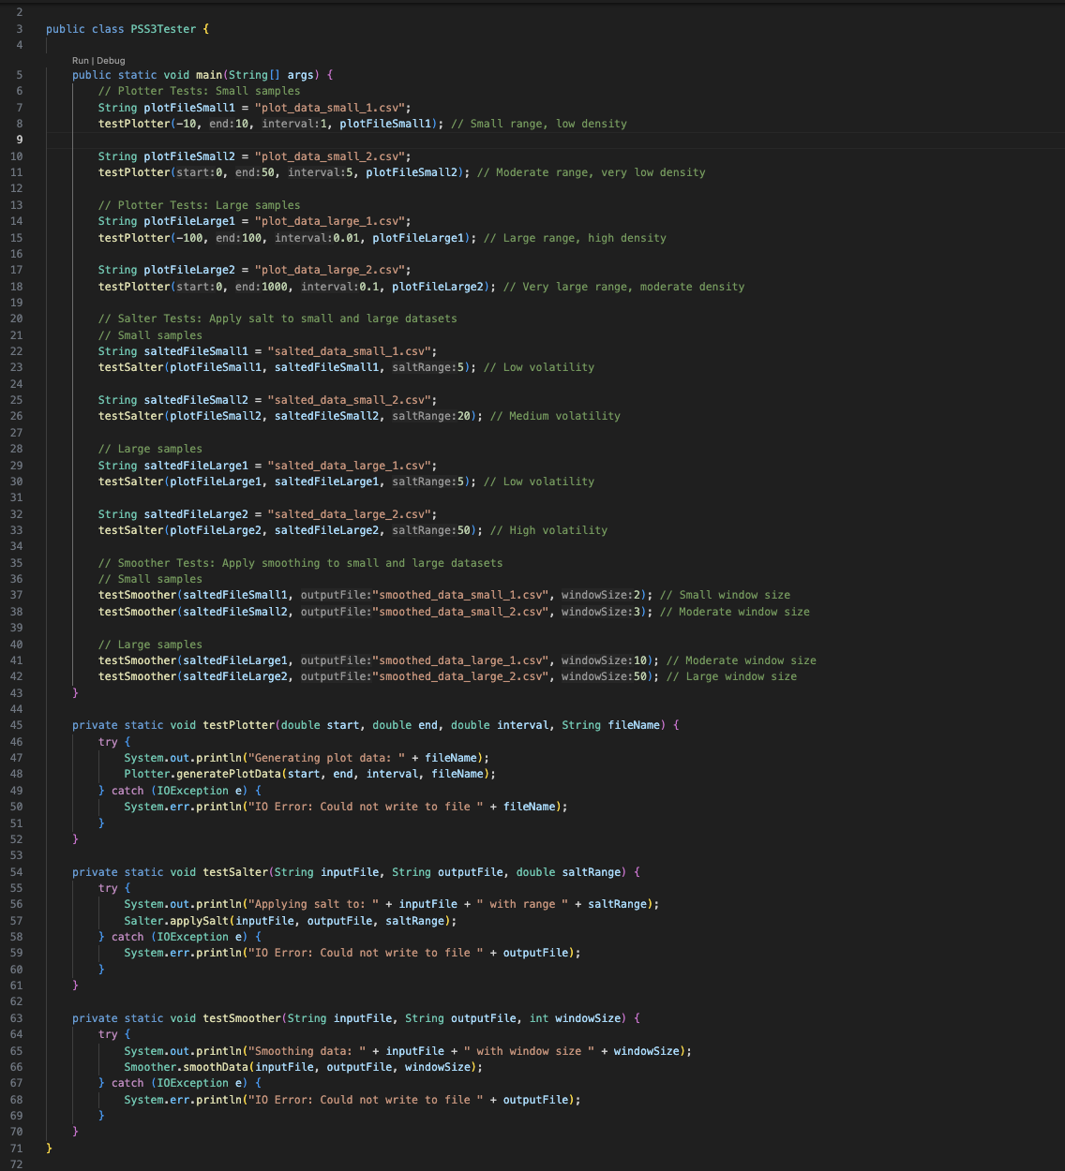

Outputs: (Graph And CSV Files)

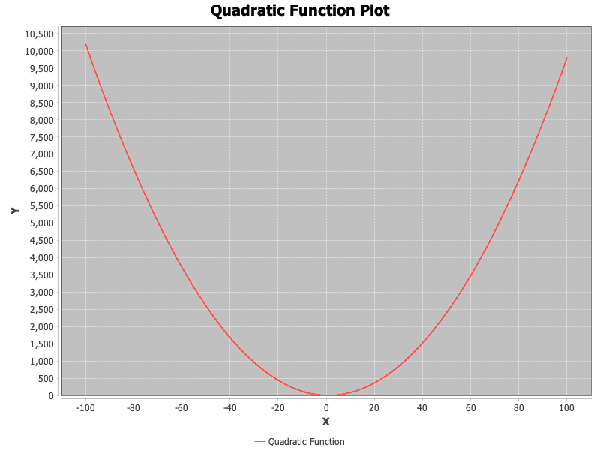

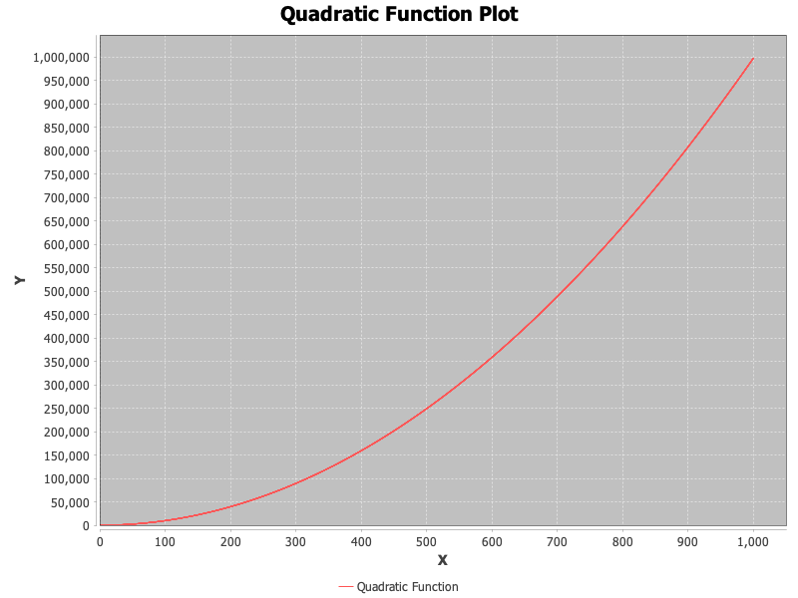

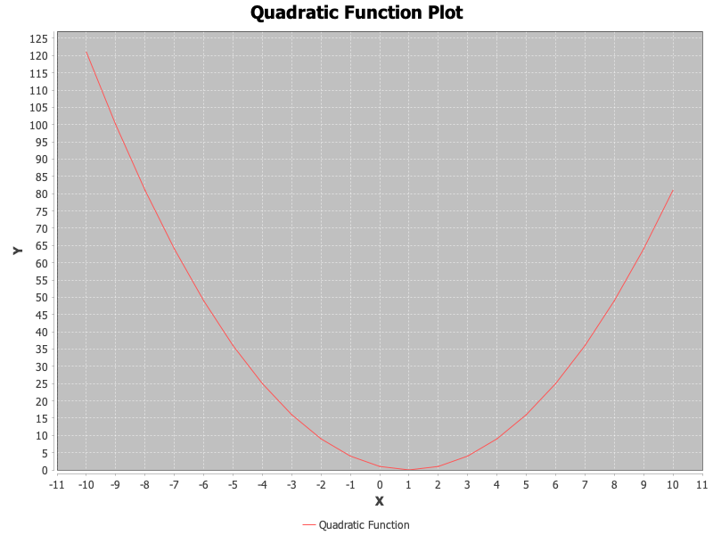

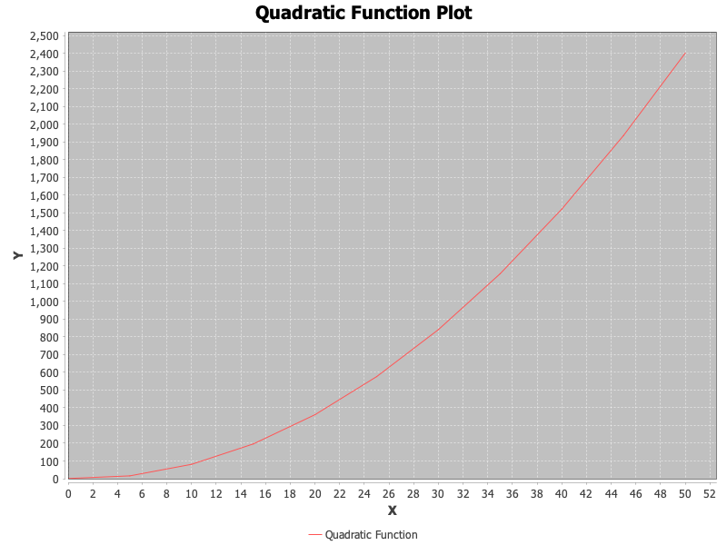

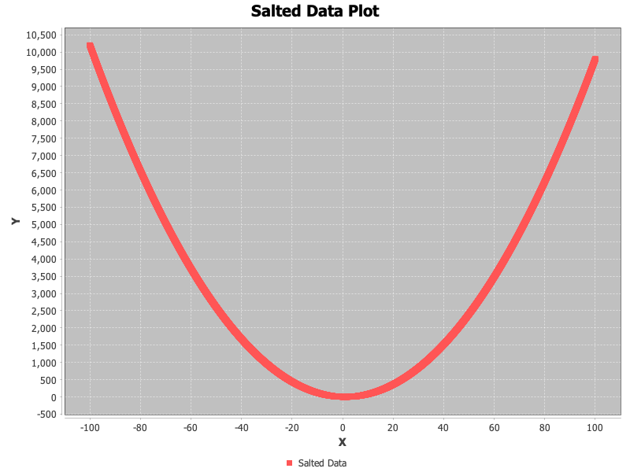

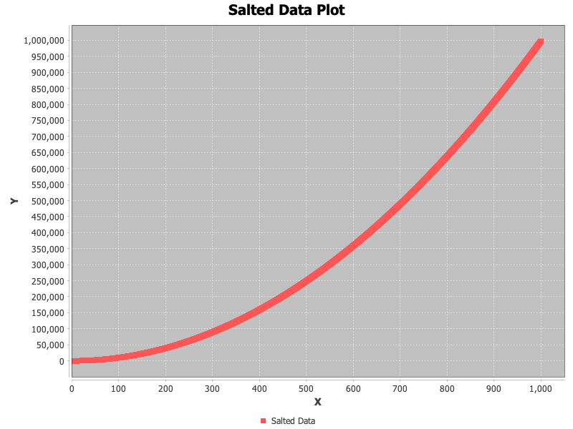

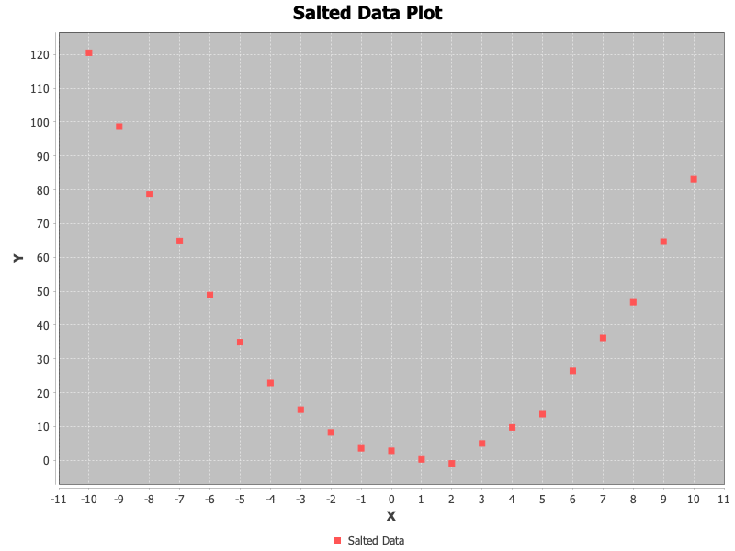

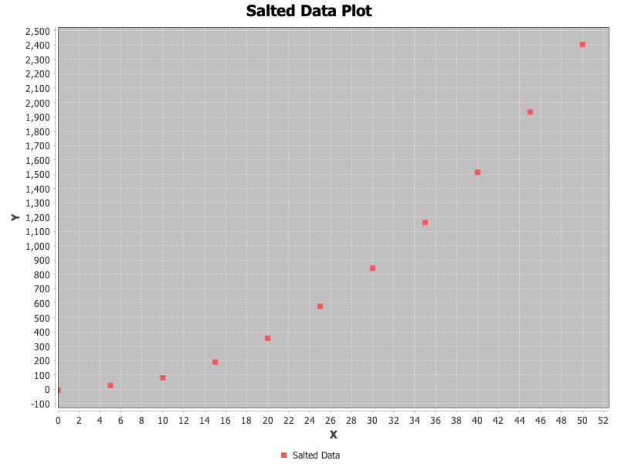

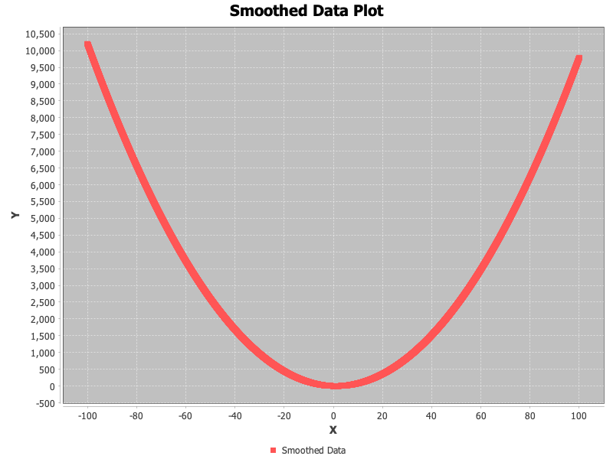

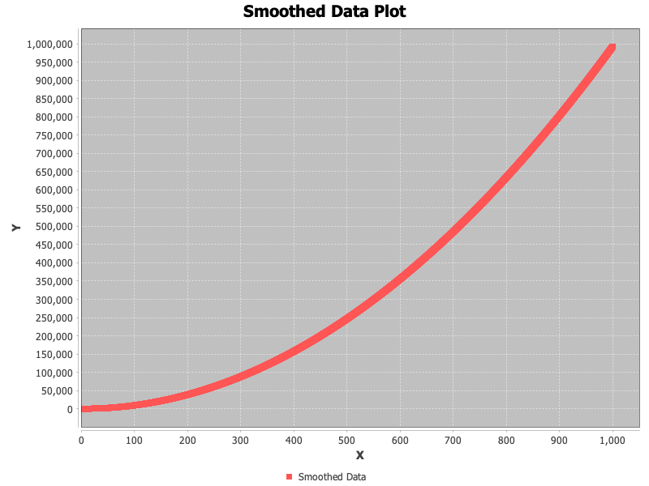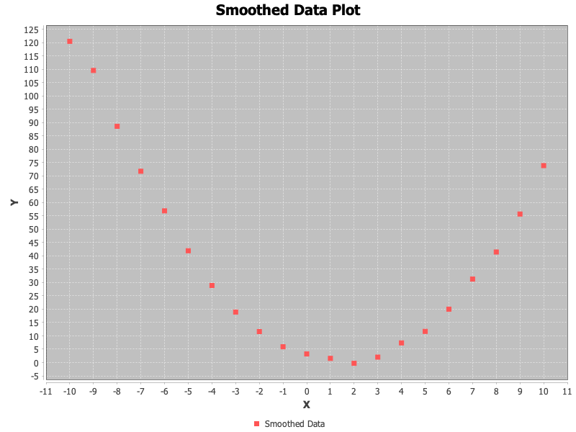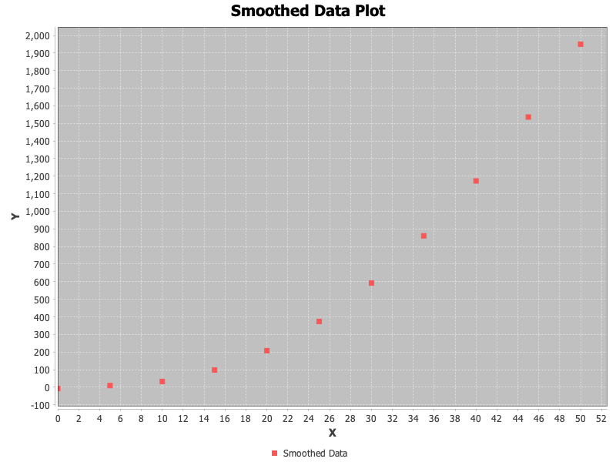

CSV FILES

#### 

#### 